Regression Analysis and Regularization Techniques on the Diabetes Dataset
Sandeep Parupalli
University of the Cumberlands
Advanced Big Data and Data Mining (MSCS-634-B01)
Instructor Satish Penmatsa
March 29, 2026

Regression Analysis and Regularization Techniques on the Diabetes Dataset
This report examines how several regression techniques perform on the diabetes dataset from scikit-learn. The main goal of the lab was to compare baseline linear models with more flexible and more strongly constrained models in order to understand how model complexity affects prediction quality. The analysis focused on simple linear regression, multiple linear regression, polynomial regression, Ridge regression, and Lasso regression. Model performance was evaluated with mean absolute error (MAE), mean squared error (MSE), root mean squared error (RMSE), and R-squared (R2).
Data Preparation
The diabetes dataset contains 442 observations and 10 standardized health-related predictors: age, sex, body mass index (BMI), blood pressure, and six blood serum measurements. The target variable is a quantitative measure of disease progression one year after baseline. After loading the data into a pandas DataFrame, the feature structure, summary statistics, and target distribution were reviewed to confirm that the data were suitable for regression analysis.
No missing values were found in either the predictors or the target, so no imputation or row deletion was required. Because the features are already standardized in the scikit-learn version of the dataset, the preparation stage focused mainly on exploratory review rather than extensive cleaning. The strongest single correlation with the target was BMI (r = 0.59), which supported using BMI as the independent variable in the simple linear regression model.
Figure 1
Distribution of the Diabetes Disease Progression Target
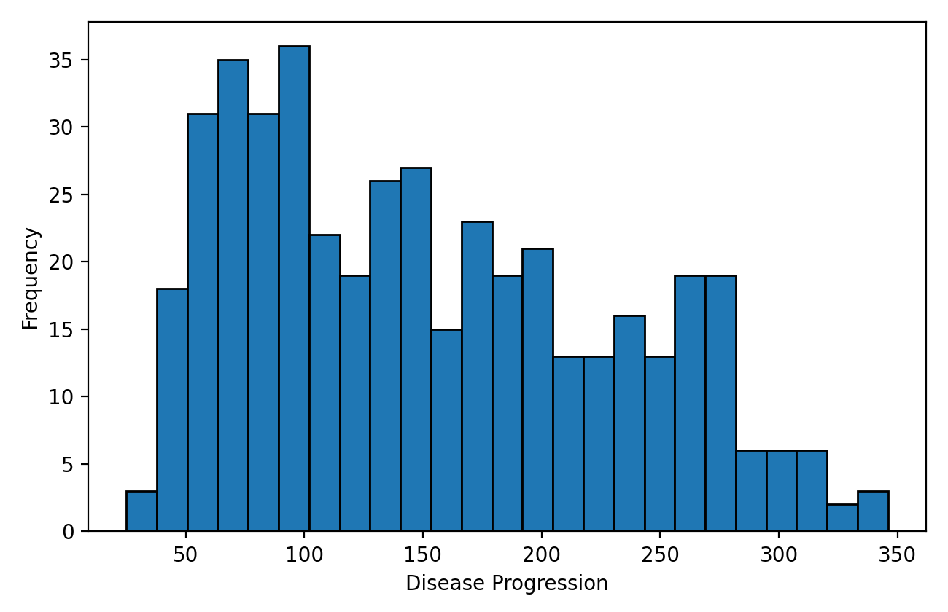
Methodology
Simple Linear Regression
The first model used simple linear regression with BMI as the only predictor. This model served as a baseline because it showed how much predictive value could be obtained from one clinically meaningful feature by itself. The dataset was split into training and testing sets using an 80/20 split with random_state set to 42 so that all later models could be compared on the same test set.
Figure 2
BMI and Disease Progression With the Simple Linear Regression Fit
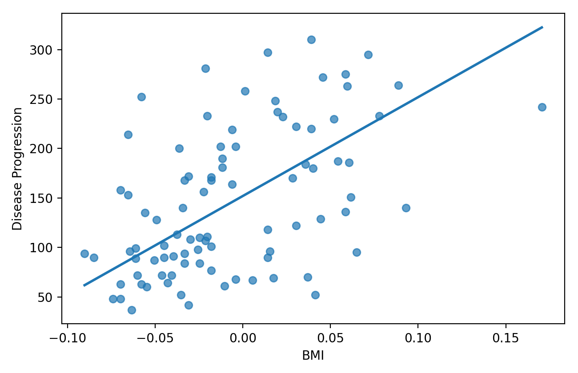
Multiple Linear Regression
The second model used ordinary least squares multiple regression with all 10 predictors. This approach incorporated more information than the single-feature model and provided a stronger linear baseline for the rest of the analysis. Predicted values were compared with the observed test values to evaluate how closely the fitted relationship generalized to unseen data.
Figure 3
Actual and Predicted Values for the Multiple Linear Regression Model
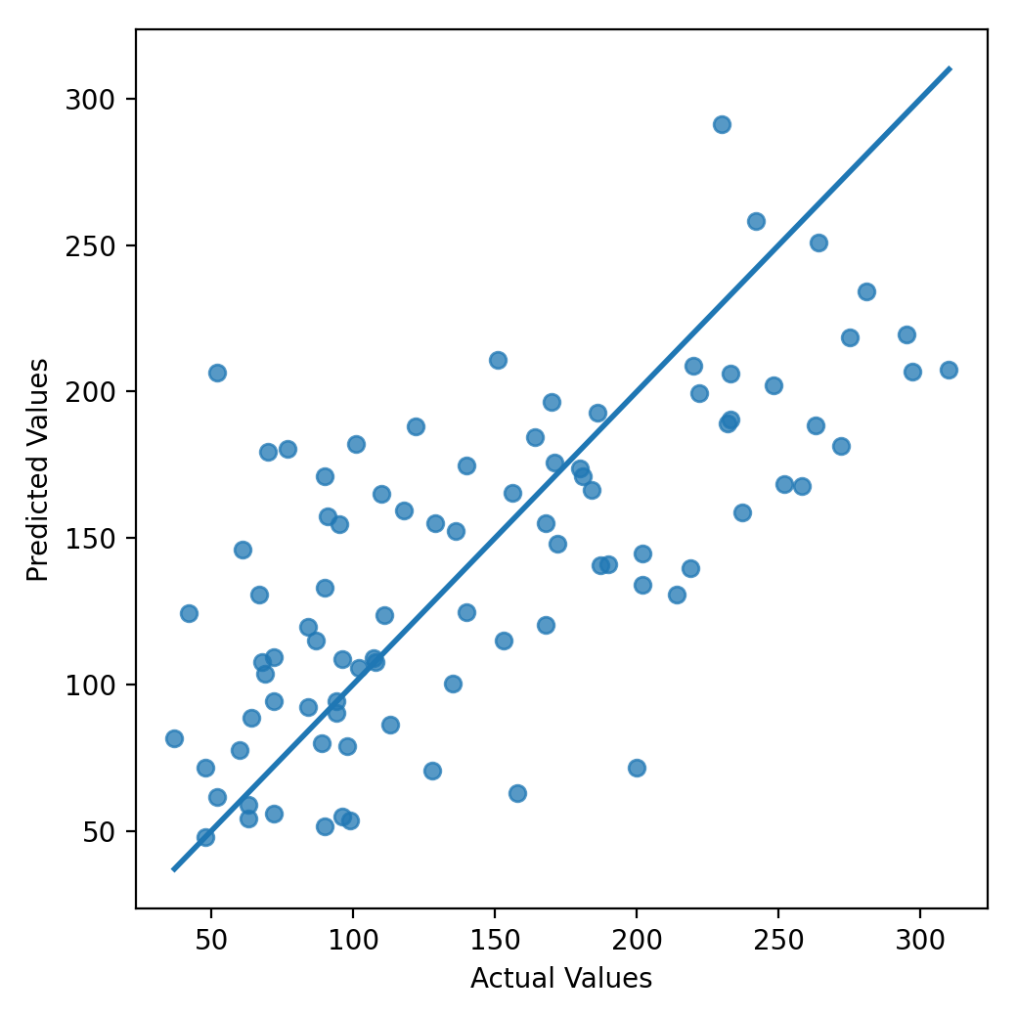
Polynomial Regression
Polynomial regression was used to extend the linear model by adding interaction terms and higher-order effects. Degree 2 and degree 3 polynomial transformations were fit with the same train-test split. This comparison was included to show how increasing model flexibility can improve the fit to training data while also increasing the risk of overfitting.
Ridge and Lasso Regression
Regularized regression was then applied with Ridge and Lasso models. Because regularization penalties are sensitive to feature scale, a StandardScaler transformation was included before each model. Alpha values of 0.01, 0.1, 1.0, 10.0, and 100.0 were tested for both methods. Ridge regression shrinks coefficients toward zero while retaining all predictors, whereas Lasso regression can set some coefficients exactly to zero and therefore acts as a form of feature selection.
Figure 4
Test RMSE Across Alpha Values for Ridge and Lasso Regression
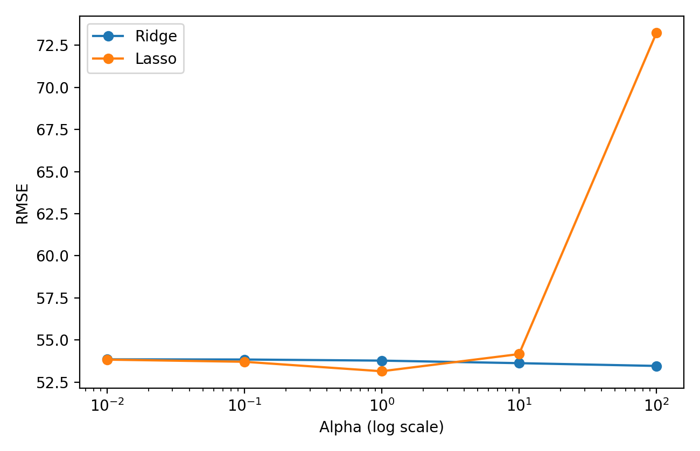
Note. Lower RMSE values indicate better out-of-sample performance.
Results
Table 1 summarizes the test-set performance of the major models. Lower MAE, MSE, and RMSE values indicate better predictive accuracy, while higher R2 values indicate that a larger share of the outcome variance is explained by the model.
Table 1
Test-Set Performance Comparison of Regression Models
Model | MAE | MSE | RMSE | R2
Lasso Regression (alpha=1.0) | 42.80 | 2824.57 | 53.15 | 0.47
Ridge Regression (alpha=100.0) | 43.25 | 2858.22 | 53.46 | 0.46
Multiple Linear Regression | 42.79 | 2900.19 | 53.85 | 0.45
Polynomial Regression (Degree 2) | 43.58 | 3096.03 | 55.64 | 0.42
Simple Linear Regression (BMI only) | 52.26 | 4061.83 | 63.73 | 0.23
Polynomial Regression (Degree 3) | 164.85 | 82446.05 | 287.13 | -14.56
Note. Lower MAE, MSE, and RMSE values indicate better performance, whereas higher R2 values indicate stronger explanatory power.
The simple linear regression model produced an RMSE of 63.73 and an R2 of 0.23, which showed that BMI alone provided some useful signal but did not explain the outcome particularly well. Multiple linear regression improved performance substantially, lowering RMSE to 53.85 and increasing R2 to 0.45. The degree 2 polynomial model did not improve on the multiple linear baseline on the test data (RMSE = 55.64), and the degree 3 model performed dramatically worse on the test set.
The overfitting pattern in the degree 3 polynomial model was especially clear because its training R2 reached 0.88, while its test R2 fell to -14.56. This large gap showed that a highly flexible model can memorize training patterns that do not generalize. Among the regularized models, the best Ridge model used alpha = 100.0 and achieved an RMSE of 53.46. The best Lasso model used alpha = 1.0 and achieved the lowest RMSE in the study at 53.15, with an R2 of 0.47.
Discussion
The comparison across models showed that additional predictors were more valuable than additional polynomial complexity for this dataset. Moving from one predictor to all 10 predictors clearly improved accuracy, but moving from a linear form to a higher-degree polynomial form did not improve test performance. In fact, the degree 3 polynomial model demonstrated how quickly overfitting can appear when the number of derived features becomes too large relative to the sample size.
Regularization improved the results modestly but meaningfully. Ridge regression was stable across the tested alpha values and produced its best performance at the strongest penalty in the grid. Lasso regression performed best at a moderate alpha value of 1.0 and retained nine nonzero coefficients, which suggests that most of the predictors still contributed information while one predictor was effectively removed. When alpha increased to 100.0, Lasso eliminated all coefficients and the model underfit, which confirmed that an excessively strong penalty can erase useful signal along with noise.
The diabetes dataset also provided several practical insights. BMI had the strongest single-feature relationship with the target, which is why the simple linear model was built around BMI. However, the large difference between the simple and multiple linear results showed that disease progression is not explained well by one measurement alone. The best-performing models remained linear in structure but used either all predictors or moderate coefficient shrinkage, which indicates that this dataset benefits more from balanced regularization than from aggressive nonlinear expansion.
Conclusion
Overall, the lab demonstrated the trade-off between simplicity, flexibility, and generalization in regression modeling. Simple linear regression provided a useful starting point, multiple linear regression established a strong baseline, polynomial regression exposed the risk of overfitting, and Ridge and Lasso regression showed how regularization can improve robustness. The best overall result came from Lasso regression with alpha = 1.0, which achieved an RMSE of 53.15 and an R2 of 0.47. These findings support the conclusion that moderately regularized linear models are the most appropriate choice for this version of the diabetes prediction task.
The notebook and README associated with this lab are available in the public GitHub repository: https://github.com/Sandeep271/Lab-4-Regression-Analysis-with-Regularization-Techniques

